**SOFTWARE ENGINEERING**

**PROJECT REPORT**

**TRAVEL BUDDY**

BY:

NANDITA SHUKLA 16BCE0553

MEENAKSHI DAS 16BCE0560

ABINASH SATAPATHY 16BCE0081

GUIDED BY:PROF. SHASHANK MOULI SATAPATHY



APRIL-2018

TABLE OF CONTENTS:

1.ABSTRACT

2.INTRODUCTION

3.REQUIREMENT SPECIFICATION

4.PROCESS MODEL IDENTIFICATION

5.WORK BREAKDOWN STRUCTURE

6.ACTIVITY NETWORK

7.GANTT CHART

8.ENTITY RELATIONSHIP DIAGRAM

9.DATA FLOW DIAGRAM

10.DATA DICTIONARY

11.CRITICAL PATH IDENTIFICATION

12.SOFTWARE DESIGN SPECIFICATION

13.TEST CASE

14.USER MANUAL

**ABSTRACT**

Nowadays, we can find many interactive applications and mobile services accessible

everywhere. Usually, these services have been designed to serve a unique target population,

independent for instance; of the kind of devices the users have or the particular situation the

users are encountered. Thus according to the requirement, it would be appropriate to have a

travel buddy service specialized for students of a college to get companion to travel with to the

airport, or the same city etc. Finding a person to travel with has many advantages those include

company, safety, monetary savings, less waste of resources, making friends, etc. Our project aim

is to build the database for such a system and also provide the web interface for it. For solving

this problem we will be creating a database of details, and then using exceptional handling to

manage it. Sorting will be done from the data taken from the user and implementing database

management techniques known to us Starting from the scratch ,entity relationship diagram we

build up normalized form of the data needed reducing deletion and insertion anomalies . Thus

we will help in reducing the cost of travel and also facilitating the experience of a journey by

forming travel buddies which is a much better alternative than travelling alone.

We can test it and take reviews if people would make use of such a system by giving

them a demo after the project completion. If we have a good response we can launch it as an

open source project in VIT and then extend to other colleges as well.

**INTRODUCTION**

As urbanization is increasing, people mostly prefer to travel mostly by cars or cabs. This increases the demand for cabs during peak hours. Increasing cabs might sound a good solution but it has its own adverse effects as it increases traffic, cost, fuel consumption, pollution, etc. Most of the surveys in cab rental industries show that carpooling not only reduces pollution, but also saves fuel to a large extent. Carpooling has gained its popularity not only because of its environmental friendly nature, also because it’s pocket friendly and one way of becoming social. Usually it is hard to find people going to the same place as you are, so lot of people have designed many applications and websites for carpooling. The drawbacks of these applications are the limitation to a particular location and platforms. Many of the cab sharing systems that have been implemented use the ride-matching protocol. The protocol is designed in such a way that it fulfils the travelers request without having any prior knowledge of the travel details. The advantage of this protocol is that it searches for a fuel saving ride and eases traffic congestion.

Carpooling is very useful for college students as it not only reduces the travel cost but also gives them an opportunity to interact with people. Many times students feel unsafe and scary to travel alone to a long distance city, also the journey becomes very lonely and boring. Our paper aims at solving this problem by grouping the travelers travelling to the same place at the same time. This is easily possible at the semester end and semester beginning as the dates for travel range between a couple of days and easily match with numerous other students. Also the travelling destinations are standard like airports, railway stations, tourist destinations in the vicinity of the college, etc. The paper aim is to design a web application which allows user to enter their trip details based on which they can find a match for the ride. The people with an existing group can accept or decline requests from a new user based on their convenience. This gives the users an option to choose the people they travel with.

**REQUIREMENT SPECIFICATION**

**1.Functional requirements:**

Requirement1.1:Create Trip

Description:When an authenticated user logs in from their account or when a person signs up they get an option to create a new trip .The user has to select:

• the vehicle type

• the number of passengers for the journey

• the date of the journey

• the source

• the destination.

This function is initiated after login/signup after the user selects the create trip option from the user window.

The user that creates a new trip becomes the trip admin for the trip.

Requirement1.2:Request for join

Description:When the user logs in , he/she is directed to the user window wherein if he chooses the option for ‘request for join’ , he gets a detailed view of the existing cabs for the trips that other users have already created.

1.2.1-The user can then send a request to join an existing trip to the trip admin.

1.2.2-The user can sort the search for the existing cabs by the source, destination or the date of travel.

1.2.3-Request Response-The user window initiates another function i.e. the request response which has two primary sub-requirements:

1.2.3a-For a trip that the user acts as an admin, the user can accept or decline the requests for other users based on their details.

1.2.3b-For a trip that the user has requested , the status (accepted/pending/declined) can be viewed by the user.

Requirement1.3:Contact sharing

The users can view the contact details of the admin and vice-versa if the contact sharing option is enabled by the users for a certain trip or for everyone.

1.3.1Confirmation Message-The user gets notified if his cab is cab request gets confirmed .The confirmation is through email and sms to the email address and the contact number provided respectively.

Requirement 1.4:Status of the cab

Description:The users can see the location of the cab right now .This functional requirement tracks the gps of the cab.

Requirement 1.5:Travel agency:

Description:The users can choose from which travel agencies they want the car by analyzing the availability of cars and different rates.

**2.Non functional requirements:**

2.1System should accept payments via payment methods that are reliable like paypal, wallets ,cards, vouchers etc.

2.2User during sign up , should be helped appropriately to fill in the mandatory fields in case of invalid input.

2.3 System should visually confirm as well as send booking confirmation to user’s contacts .

**PROCESS MODEL IDENTIFICATION**

The model we are planning to use is sashimi model(a variation of waterfall model).We are planning to use this traditional model because:

• The requirements are very well known

• The specifications are very well translated from the requirements

• It is a predictive model because we know the solution very well

• It is a waterfall model that shortens the development type by overlapping certain phases (since we have less time for development)

**WORK BREAKDOWN STRUCTURE**

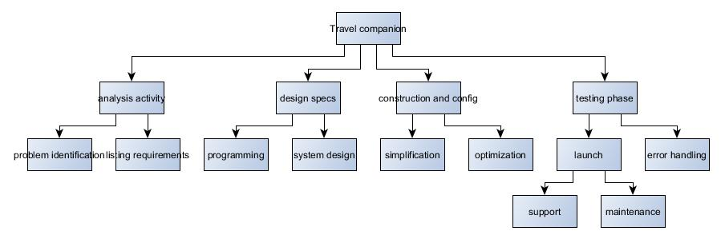

**ACTIVITY NETWORK**

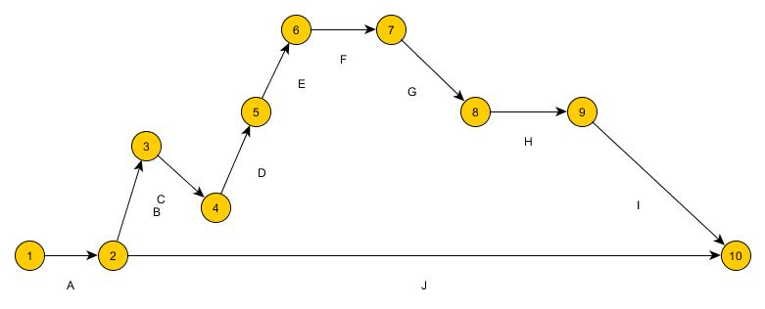

|  |  |  |  |  |
| --- | --- | --- | --- | --- |
|  | ACTIVITY |  |  | DURATION |
| A | SET UP ACQUISITION TEAM | | | 1 week |
| B | WRITE DOWN SOFTWARE REQUIREMENTS | | | 3 weeks |
| C | DETERMINE OBJECTIVES | |  | 1 week |
| D | SECURE BUDGET | |  | 1 week |
| E | SELECT STACKHOLDER | |  | 1 week |
| F | STACKHOLDER REVIEW | |  | 1 week |
| G | SYSTEM CHECK |  |  | 2 weeks |
| H | PRODUCTION |  |  | 4 weeks |
| I | WRAP UP AUDIT |  |  | 1 week |
| J | ANALYSE RESULTS | |  | 1 week |

**GANTT CHART**

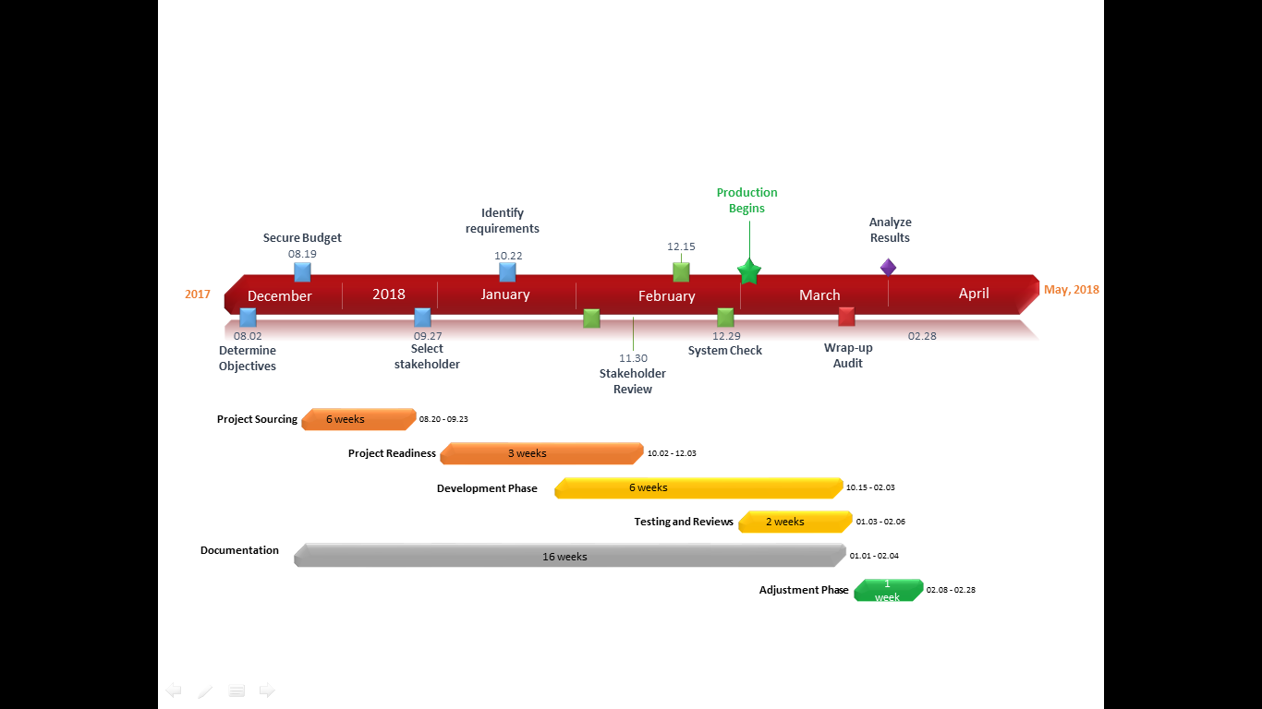

**E-R DIAGRAM**

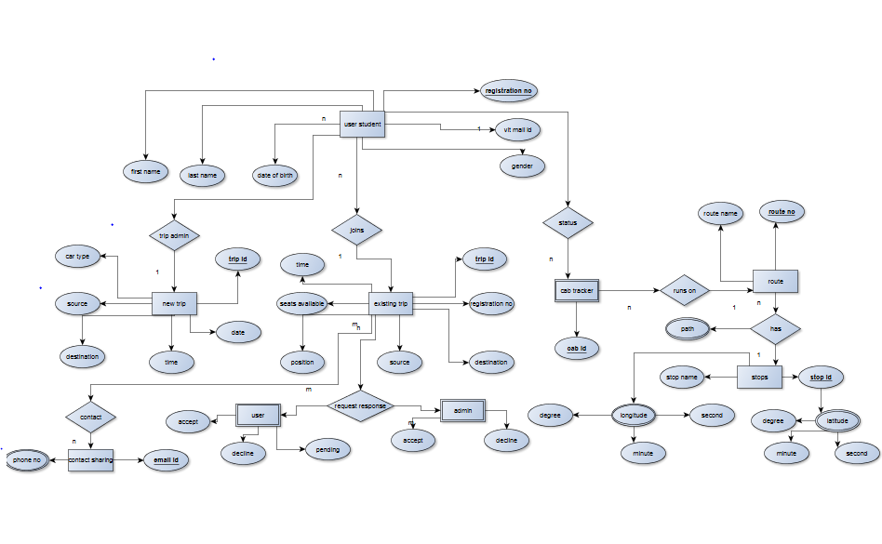

**DATA FLOW DIAGRAM**

**LEVEL 0:**

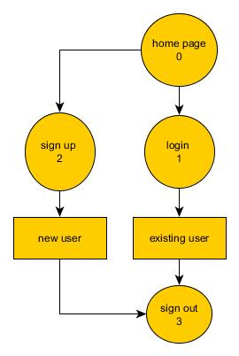

**LEVEL 1:**

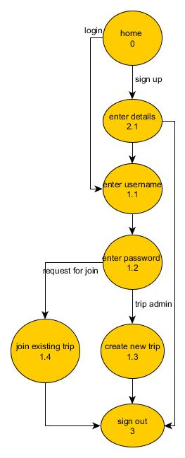

**LEVEL 2:**

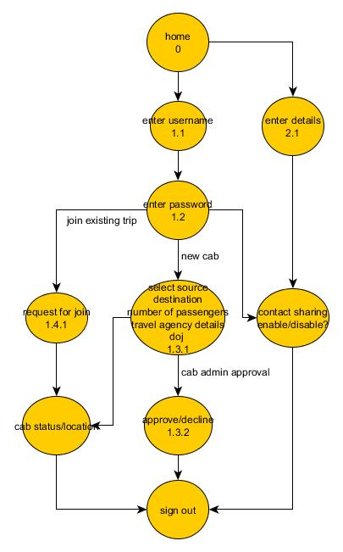

**DATA DICTIONARY**

User name: Alphanumeric * input to be taken *

Password: Alphanumeric + Special characters * input to be taken *

Error: String * Error message to be displayed (preferably a pop-up) *

Source: String *Input – name of a city *

Destination: String * Input – name of the city Destination ≠ Source *

Vehicle type: String

Nop: Integer * Number of passengers to be entered *

Doj: Date format * Date of journey *

Contact: Integer * Phone number of user *

Email: Alphanumeric

**CRITICAL PATH IDENTIFICATION**



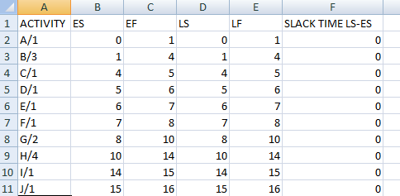

**SOFTWARE DESIGN SPECIFICATION**

**STRUCTURE CHART:**

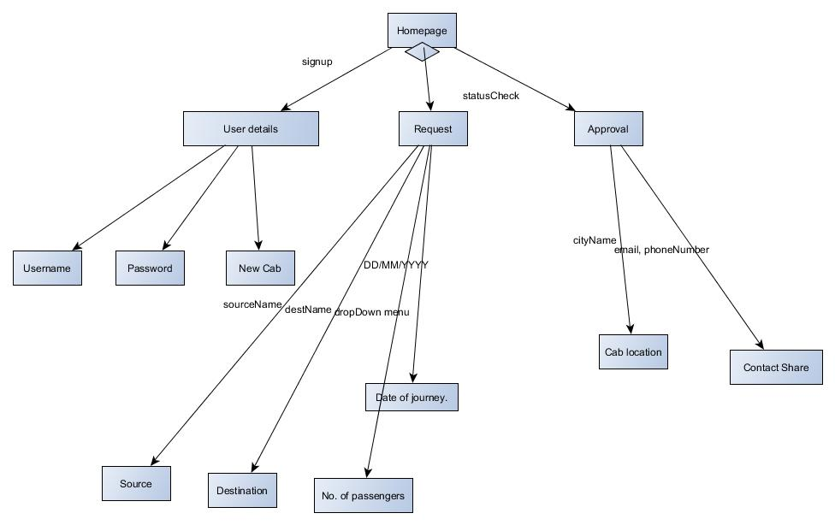

**USE CASE DIAGRAM:**

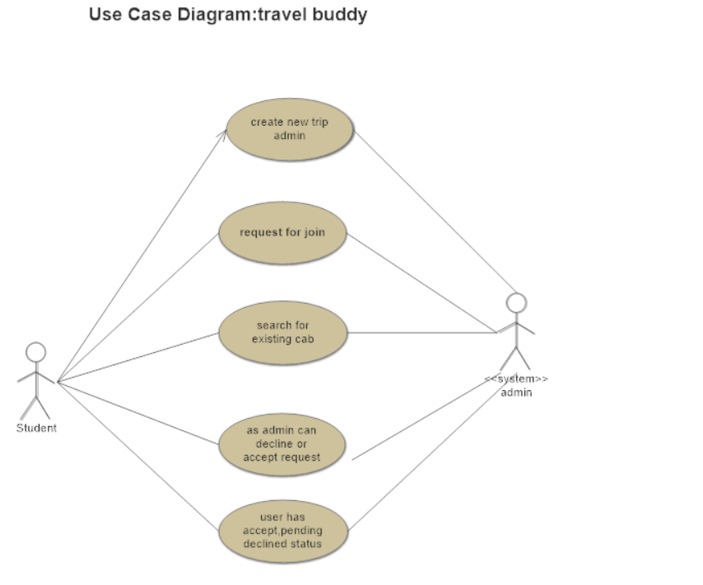

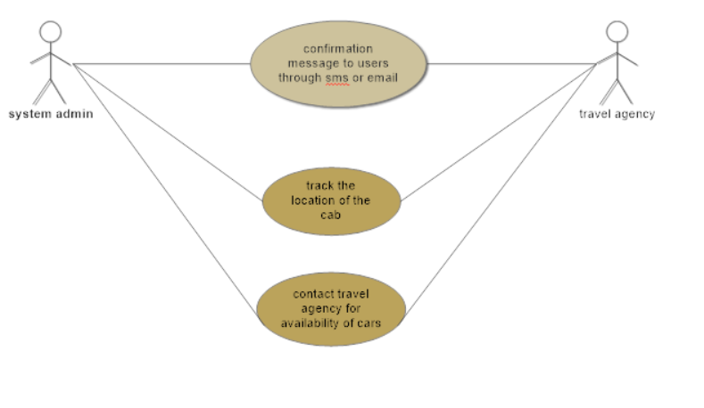

**USE CASE DESCRIPTION:**

|  |  |  |  |  |
| --- | --- | --- | --- | --- |
| Use Case ID: | UC_001 | | | |
| Use Case Name: | Booking of the cab | | | |
| Created By: |  | | Last Updated By: |  |
| Date Created: |  | | Date Last Updated: |  |
| Actor: | | Student/faculty,system admin | | |
| Description: | | When user logs in,homepage appears where user fills up the details, create new trip and become admin,request for join in exisiting cabs,as admin can approve/decline request of other user,user can wait for approval/decline/pending from admin. | | |
| Preconditions: | | User viewing the options to become a new admin or join in exisiting cabs.. | | |
| Postconditions: | | The cab location will be seen in system admin,the details of cabs can be seen | | |
| Priority: | |  | | |
| Frequency of Use: | | 40% of users opt to be admin and 60% users opt for rquest of exisiting cabs. | | |
| Normal Course of Events: | | 1.user logs in through user name and password and system admin makes sure username is unique.  2.user if creating a new trip then becomes admin and fills on the details .  3.if the user wants to join exisiting cabs then searches for it and send request.  4.as soon as cab is booked the system admin send sms or email regarding the cab details. | | |
| Alternative Courses: | | 1.System admin determines the user is already logged in then return to step 1.  2.When users logs off again,then home page appears to log in.  3.If user does not have an account already,then user creates an account,system confirms account creation,returns to home page for log in. | | |
| Exceptions: | | 1. User decides to book a cab so sees booking cab use case.  2.If system fails to save the details then notifies user that an error has occurred.  3.returns to fill up details page . | | |
| Includes: | |  | | |
| Special Requirements: | | 1.System should accept payments via payment methods that are reliable like paypal, wallets ,cards, vouchers etc.  2.User during sign up , should be helped appropriately to fill in the mandatory fields in case of invalid input.  3 .System should visually confirm as well as send booking confirmation to user’s contacts . | | |
| Assumptions: | | For booking of cab the user should fill up the details accurately. | | |
| Notes and Issues: | | 1.what is the maximum size of username and password.  2.the password should contain capital letter,special character,numerical. | | |
| Exceptions: | | 1. User decides to book a cab so sees booking cab use case.  2.If system fails to save the details then notifies user that an error has occurred.  3.returns to fill up details page . | | |
| Includes: | |  | | |
| Special Requirements: | | 1.System should accept payments via payment methods that are reliable like paypal, wallets ,cards, vouchers etc.  2.User during sign up , should be helped appropriately to fill in the mandatory fields in case of invalid input.  3 .System should visually confirm as well as send booking confirmation to user’s contacts . | | |
| Assumptions: | | For booking of cab the user should fill up the details accurately. | | |
| Notes and Issues: | | 1.what is the maximum size of username and password.  2.the password should contain capital letter,special character,numerical. | | |

|  |  |  |  |  |
| --- | --- | --- | --- | --- |
| Use Case ID: | UC_002 | | | |
| Use Case Name: | Cab availability and tracking | | | |
| Created By: |  | | Last Updated By: |  |
| Date Created: |  | | Date Last Updated: |  |
| Actor: | | system admin,travel agency | | |
| Description: | | When the user fills up details the system login passes the details to travel agency to check for the availability of cabs,then according to status of travel agency sms or email is send to user by system admin.The system admin track the location of cab. | | |
| Preconditions: | | System admin can view the details of users and the availability of cars,then the gps location of the cab can be viewed. | | |
| Postconditions: | | The cab of different users can be viewed by system admin | | |
| Priority: | |  | | |
| Frequency of Use: | | 70% of work done by system admin and 30% of work done by travel agency. | | |
| Normal Course of Events: | | 1.user details are forwarded to travel agency by system admin.  2.the travel agency according to details gives the availability of cabs.  3.the system admin opts those details and forwards them to users.  4.the system admin according to different users track the location . | | |
| Alternative Courses: | | 1.System admin determines the user has given accurate details.  2.When cab details are given,the system admin should check if details are correct or not.  3.If the sms or email is enabled then sharing of contact should not be done. | | |
| Exceptions: | | 1.system admin gets the cabs by using use case cab availability and tracking.  2.If system fails to save the details then notifies system admin that an error has occurred.  3.requests the travel agency to send the details again . | | |
| Includes: | |  | | |
| Special Requirements: | | 1.System should accept payments via payment methods that are reliable like paypal, wallets ,cards, vouchers etc.  2.User during sign up , should be helped appropriately to fill in the mandatory fields in case of invalid input.  3 .System should visually confirm as well as send booking confirmation to user’s contacts . | | |
| Assumptions: | | For cab availability and tracking the details must be accurate. | | |
| Notes and Issues: | | 1.what should be the maximum cabs to be given in a day. | | |
| Normal Course of Events: | | 1.user details are forwarded to travel agency by system admin.  2.the travel agency according to details gives the availability of cabs.  3.the system admin opts those details and forwards them to users.  4.the system admin according to different users track the location . | | |
| Alternative Courses: | | 1.System admin determines the user has given accurate details.  2.When cab details are given,the system admin should check if details are correct or not.  3.If the sms or email is enabled then sharing of contact should not be done. | | |
| Exceptions: | | 1.system admin gets the cabs by using use case cab availability and tracking.  2.If system fails to save the details then notifies system admin that an error has occurred.  3.requests the travel agency to send the details again . | | |
| Includes: | |  | | |
| Special Requirements: | | 1.System should accept payments via payment methods that are reliable like paypal, wallets ,cards, vouchers etc.  2.User during sign up , should be helped appropriately to fill in the mandatory fields in case of invalid input.  3 .System should visually confirm as well as send booking confirmation to user’s contacts . | | |
| Assumptions: | | For cab availability and tracking the details must be accurate. | | |
| Notes and Issues: | | 1.what should be the maximum cabs to be given in a day. | | |

**ACTIVITY DIAGRAM:**

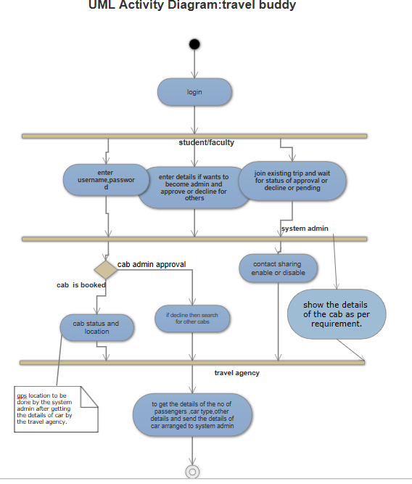

**CLASS DIAGRAM:**

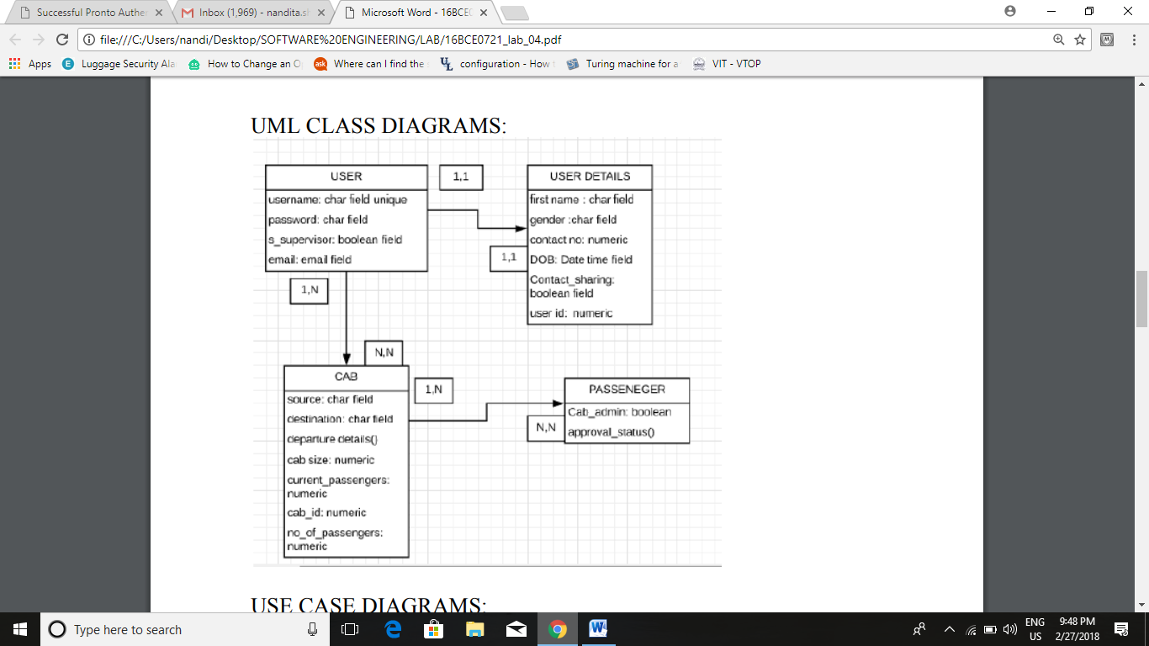

**CRC CARD:**

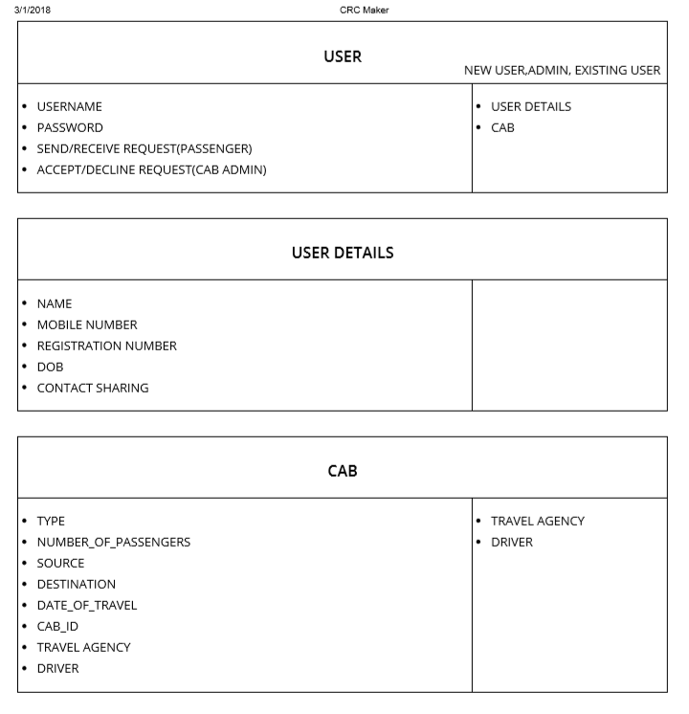

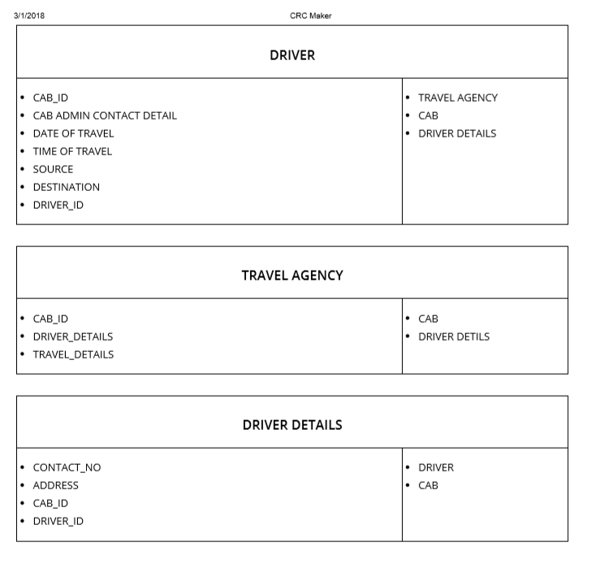

**STATE CHART DIAGRAM:**

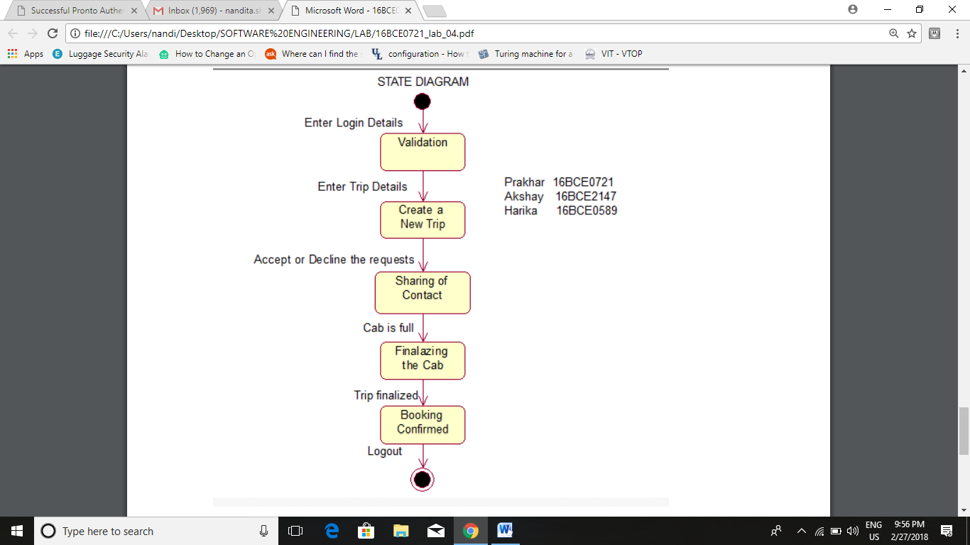

**SEQUENCE DIAGRAM:**

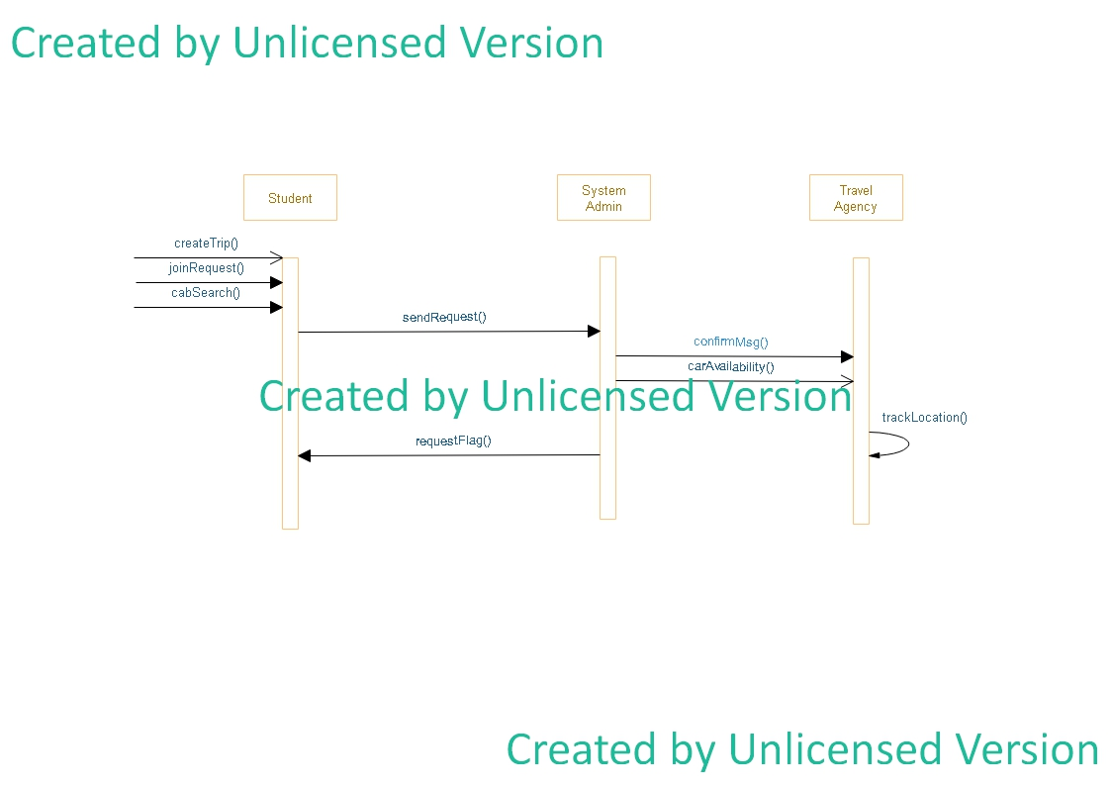

**COLLABORATION DIAGRAM:**

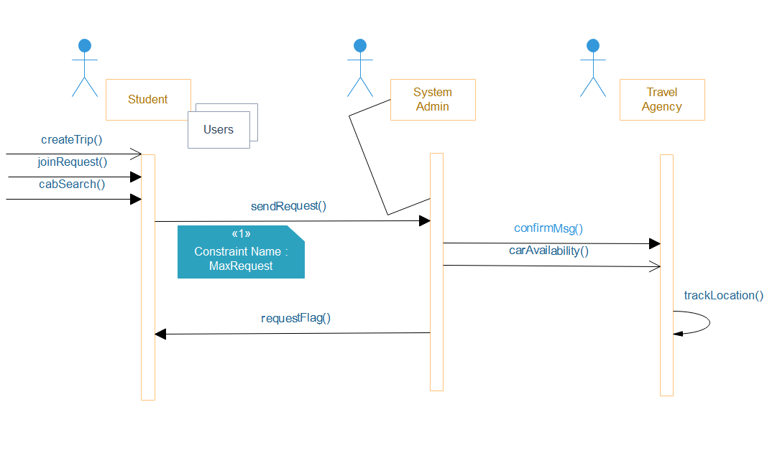

**COMPONENT DIAGRAM**

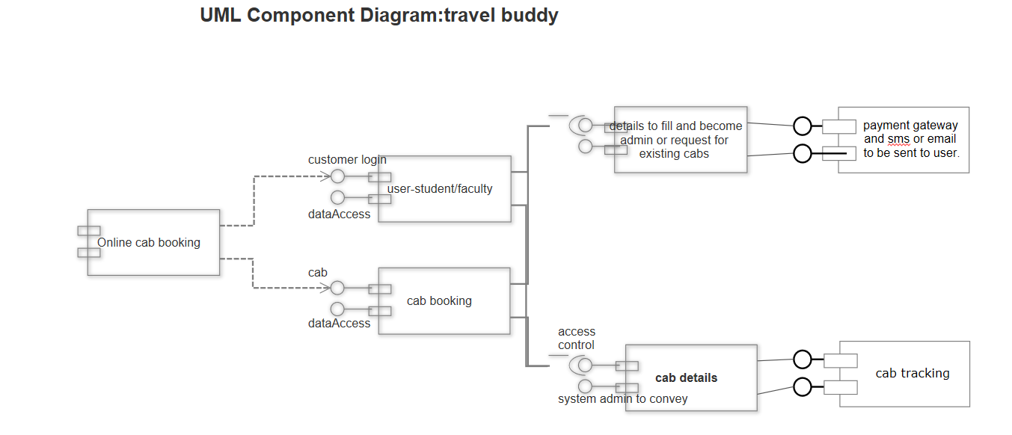

**Test Cases**

|  |  |
| --- | --- |
| **Project Name:Travel Companion** | |
| **Test Case Template** | |
| **Test Case ID:**Fun_1 | **Test Designed by:**Abinash Satapathy |
| **Test Priority (Low/Medium/High):**High | **Test Designed date:**20/03/2018 |
| **Module Name: Login** | **Test Executed by: Abinash Satapathy** |
| **Test Title:**Verify login with valid username and password | **Test Execution date:**20/03/2018 |
| **Description:**Test the credentials |  |
|  | |
| **Pre-conditions:**User has valid username and password | |
| **Dependencies:** | |

|  |  |  |  |  |  |  |
| --- | --- | --- | --- | --- | --- | --- |
| **Step** | **Test Steps** | **Test Data** | **Expected Result** | **Actual Result** | **Requirements Validated** | **Status (Pass/Fail)** |
| 1 | Navigate to login page | N/A | User should be able to login | User should be able to login | R1.1.1 | Pass |
| 2 | Provide valid username | abinash | Authenticated | Authenticated | R1.1.1 | Pass |
| 3 | Provide valid password | Asdfg1234 | Authenticated | Authenticated | R1.1.1 | Pass |
| 4 | Click on Login button | N/A |  |  | R1.1.1 | Pass |
|  |  |  |  |  |  |  |

**Post-conditions:**

User is validated with database and successfully login to account. The account session details are logged in database.

|  |  |
| --- | --- |
| **Project Name:Travel Companion** | |
| **Test Case Template** | |
| **Test Case ID:**Fun_2 | **Test Designed by:**Abinash Satapathy |
| **Test Priority (Low/Medium/High):**High | **Test Designed date:**20/03/2018 |
| **Module Name: Login** | **Test Executed by: Abinash Satapathy** |
| **Test Title:**Verify login with valid username and password | **Test Execution date:**20/03/2018 |
| **Description:**Test the credentials |  |
|  | |
| **Pre-conditions:**User has valid username and password | |
| **Dependencies:** | |

|  |  |  |  |  |  |  |
| --- | --- | --- | --- | --- | --- | --- |
| **Step** | **Test Steps** | **Test Data** | **Expected Result** | **Actual Result** | **Requirements Validated** | **Status (Pass/Fail)** |
| 1 | Navigate to login page | N/A | User should be able to login | User should be able to login | R1.1.1 | Pass |
| 2 | Provide valid username | Hacker | Invalid ID | Invalid ID | R1.1.1 | Fail |
| 3 | Provide valid password | Asdfg1234 | Unsuccessful | Unsuccessful | R1.1.1 | Fail |
| 4 | Click on Login button | N/A |  |  | R1.1.1 | Fail |
|  |  |  |  |  |  |  |

**Post-conditions:**

User is not with database and could not login to account. Session details could not be loaded and saved to Database.

|  |  |
| --- | --- |
| **Project Name:Travel Buddy** | |
| **Test Case Template** | |
| **Test Case ID:**Fun_3 | **Test Designed by:**Abinash Satapathy |
| **Test Priority (Low/Medium/High):**High | **Test Designed date:**21/03/2018 |
| **Module Name: create_trip** | **Test Executed by: Abinash Satapathy** |
| **Test Title:**Trip creation for journey | **Test Execution date:**21/03/2018 |
| **Description:**User has to create trip and set source, destination details. |  |
|  | |
| **Pre-conditions:**User has valid username and password | |
| **Dependencies:** | |

|  |  |  |  |  |  |  |
| --- | --- | --- | --- | --- | --- | --- |
| **Step** | **Test Steps** | **Test Data** | **Expected Result** | **Actual Result** | **Requirements Validated** | **Status (Pass/Fail)** |
| 1 | Navigate to login page | abinash  Asdfg1234 | User should be able to login | User should be able to login | R1.1.1 | Pass |
| 2 | Enter Source | VIT | Checked | Selected | R1.1.2 | Pass |
| 3 | Enter Destination | Bangalore | Checked | Selected | R1.1.2 | Pass |
| 4 | Enter count of passengers | 3 |  | Valid | R1.1.2 | Pass |
|  |  |  |  |  |  |  |

**Post-conditions:**

Trip is created and updated both in Database as well as in the Homepage of the user.

|  |  |
| --- | --- |
| **Project Name:Travel Companion** | |
| **Test Case Template** | |
| **Test Case ID:**Fun_4 | **Test Designed by:**MEENAKSHI DAS |
| **Test Priority (Low/Medium/High):**High | **Test Designed date:**21/03/2018 |
| **Module Name: join_request** | **Test Executed by: MEENAKSHI DAS** |
| **Test Title:**Join an existing trip | **Test Execution date:**21/03/2018 |
| **Description:**User has to join the trip from the list of trips |  |
|  | |
| **Pre-conditions:**User has valid username and password, trip is already created | |
| **Dependencies:** | |

|  |  |  |  |  |  |  |
| --- | --- | --- | --- | --- | --- | --- |
| **Step** | **Test Steps** | **Test Data** | **Expected Result** | **Actual Result** | **Requirements Validated** | **Status (Pass/Fail)** |
| 1 | Navigate to login page | meenakshi  zxcv1234 | User should be able to login | User should be able to login | R1.1.1 | Pass |
| 2 | Select trip from list | Choose | Request window opens | Request window opens | R2.1.1 | Pass |
| 3 | Choice to join | Approve | Successful | Successful | R2.1.2 | Pass |
|  |  |  |  |  |  |  |

**Post-conditions:**

User request is validated. Same updates done in database.

|  |  |
| --- | --- |
| **Project Name:travel companion** | |
| **Test Case Template** | |
| **Test Case ID:Fun_5** | **Test Designed by:**nandita shukla |
| **Test Priority (Low/Medium/High):**high | **Test Designed date:**21st march,2018 |
| **Module Name:** contact sharing | **Test Executed by:**nandita shukla |
| **Test Title:**verification of contact sharing | **Test Execution date:**21st march,2018 |
| **Description:**Test and allow the user to enable/disable contact sharing |  |
|  | |
| **Pre-conditions:**User has valid username and password | |
| **Dependencies:** | |

|  |  |  |  |  |  |  |
| --- | --- | --- | --- | --- | --- | --- |
| **Step** | **Test Steps** | **Test Data** | **Expected Result** | **Actual Result** | **Requirements Validated** | **Status (Pass/Fail)** |
| 1 | Login to the website | Valid username and password | Navigate to the home page | Navigate to home page | R3.1 | Pass |
| 2 | Click on the user details option |  | The user is taken to the page where the user details are mentioned | The user is taken to the page where the user details are mentioned | R3.2 | Pass |
| 3 | Click on enable sharing |  | Contact sharing enabled | Contact sharing enabled | R3.3 | Pass |
| 4 | Click on message confirmation |  | The user receives confirmation message on the contact details provided | The user receives confirmation message on the contact details provided | R3.4 | Pass |
|  |  |  |  |  |  |  |

**Post-conditions:**

User is validated with database and successfully login to account. The account session details are logged in database.

|  |  |
| --- | --- |
| **Project Name: TRAVEL COMPANION** | |
| **Test Case Template** | |
| **Test Case ID:** Fun_6 | **Test Designed by:** MEENAKSHI DAS |
| **Test Priority (Low/Medium/High):** Med | **Test Designed date:** 20TH MARCH,2018 |
| **Module Name:** GPS Location | **Test Executed by:** MEENAKSHI DAS |
| **Test Title: location of cab** | **Test Execution date:** 21TH MARCH,2018 |
| **Description:** Test location of cab based on gps |  |
|  | |
| **Pre-conditions:** cab should be confirmed | |
| **Dependencies:** | |

|  |  |  |  |  |  |  |
| --- | --- | --- | --- | --- | --- | --- |
| **Step** | **Test Steps** | **Test Data** | **Expected Result** | **Actual Result** | **Requirements Validated** | **Status (Pass/Fail)** |
| 1 | Go to login page | Valid username and password  Meenakshi  Zxcv1234 | User should be able to login | User is navigated to the home page | R4.1 | Pass |
| 2 | Navigate to current trip | Source and destination | Authorized passenger is allowed access to cab details | User is taken to the cab options and satus page | R4.2 | Pass |
| 3 | Navigate to status of the cab |  | The gps location of the cab is made available to user | The gps location of the cab is made available to user | R4.3 | Pass |
| 4 |  |  |  |  |  |  |
|  |  |  |  |  |  |  |

**Post-conditions:**

User is validated with database and successfully login to account. The account session details are logged in database.

|  |  |
| --- | --- |
| **Project Name:travel companion** | |
| **Test Case Template** | |
| **Test Case ID:Fun_7** | **Test Designed by:**nandita shukla |
| **Test Priority (Low/Medium/High):**medium | **Test Designed date:**20th march,2018 |
| **Module Name: Travel agency** | **Test Executed by:**nandita shukla |
| **Test Title:**confirmation of booking from travel agency | **Test Execution date:**21th march,2018 |
| **Description:**to test the booking agency confirmation |  |
|  | |
| **Pre-conditions:**User has valid username and password | |
| **Dependencies:** | |

|  |  |  |  |  |  |  |
| --- | --- | --- | --- | --- | --- | --- |
| **Step** | **Test Steps** | **Test Data** | **Expected Result** | **Actual Result** | **Requirements Validated** | **Status (Pass/Fail)** |
| 1 | Login to the website | Valid username and password | The user is redirected to the home page after authenticating the details | The user is redirected to the home page after authenticating the details |  | Pass |
| 2 | Navigate to booking confirmation page | Cab request id | It either shows that the booking has been confirmed or denied | It either shows that the booking has been confirmed or denied |  | Pass |

**Post-conditions:**

User is validated with database and successfully login to account. The account session details are logged in database.

**Screenshots and Working:**

Compile procedure:

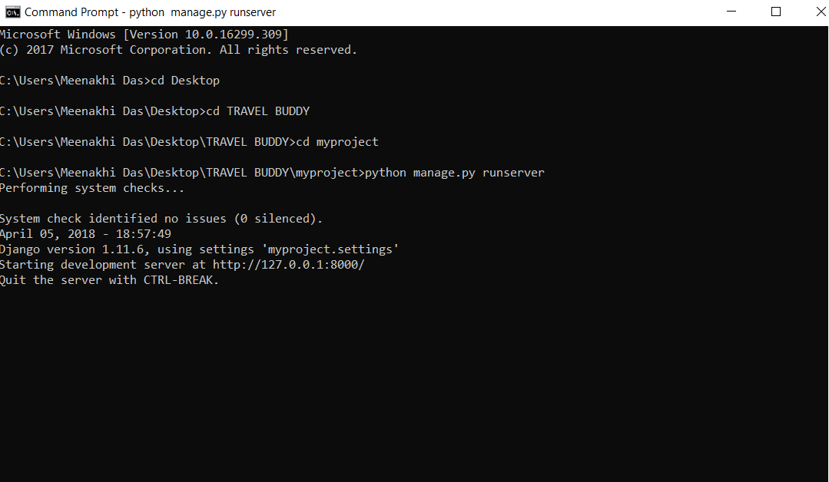

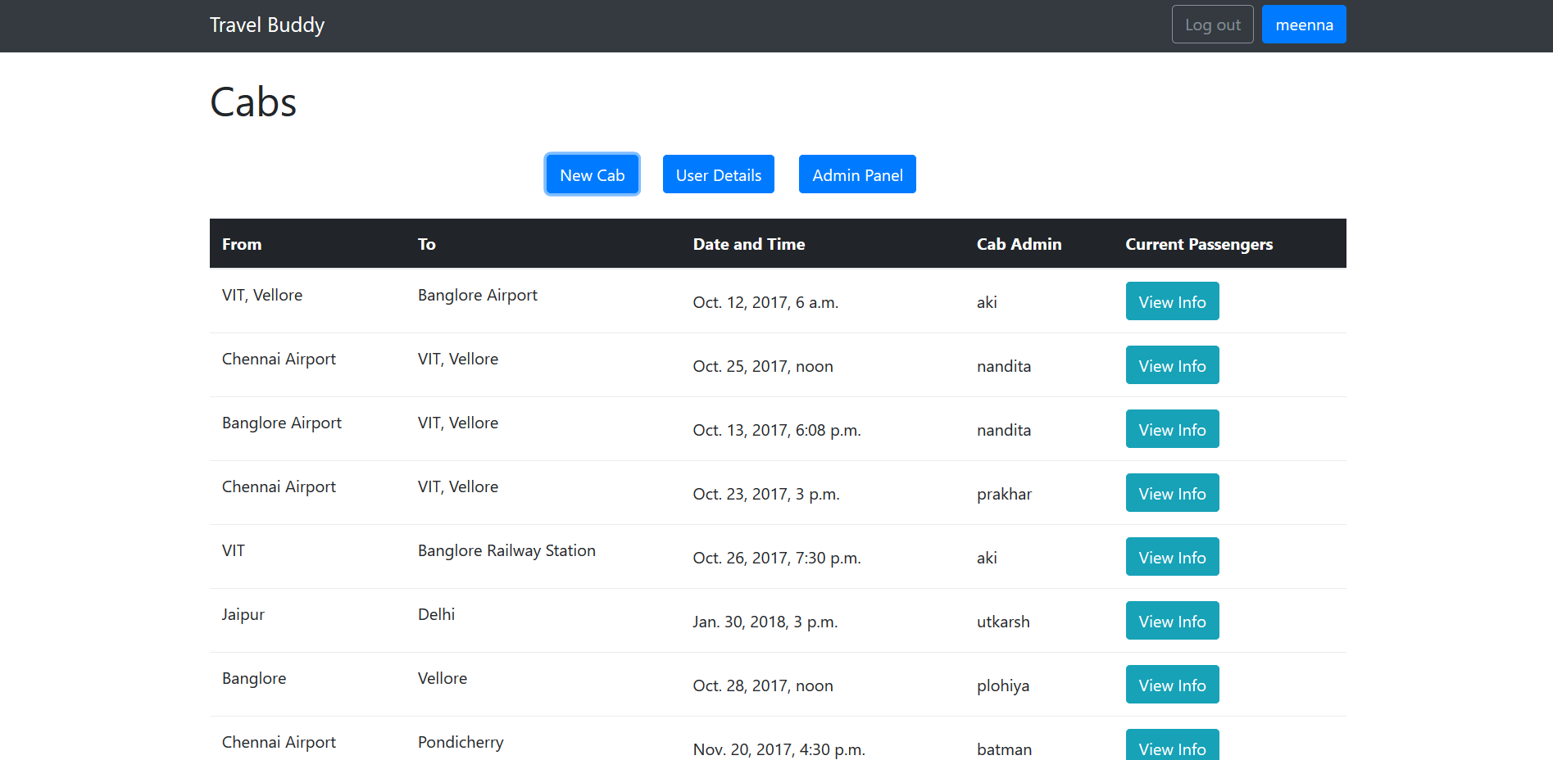

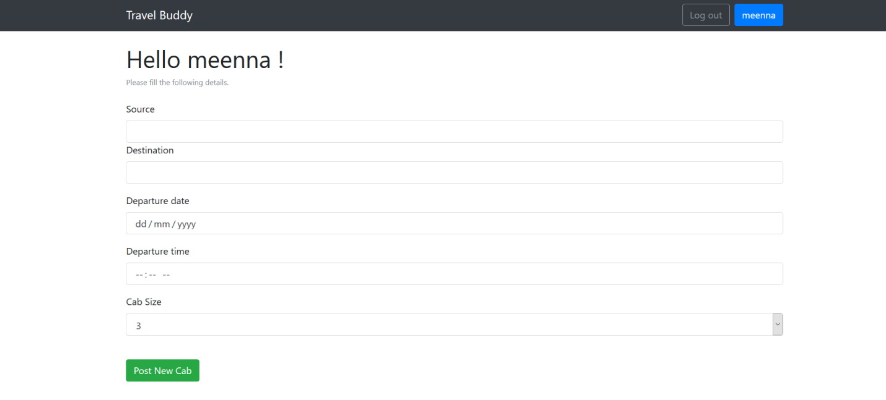

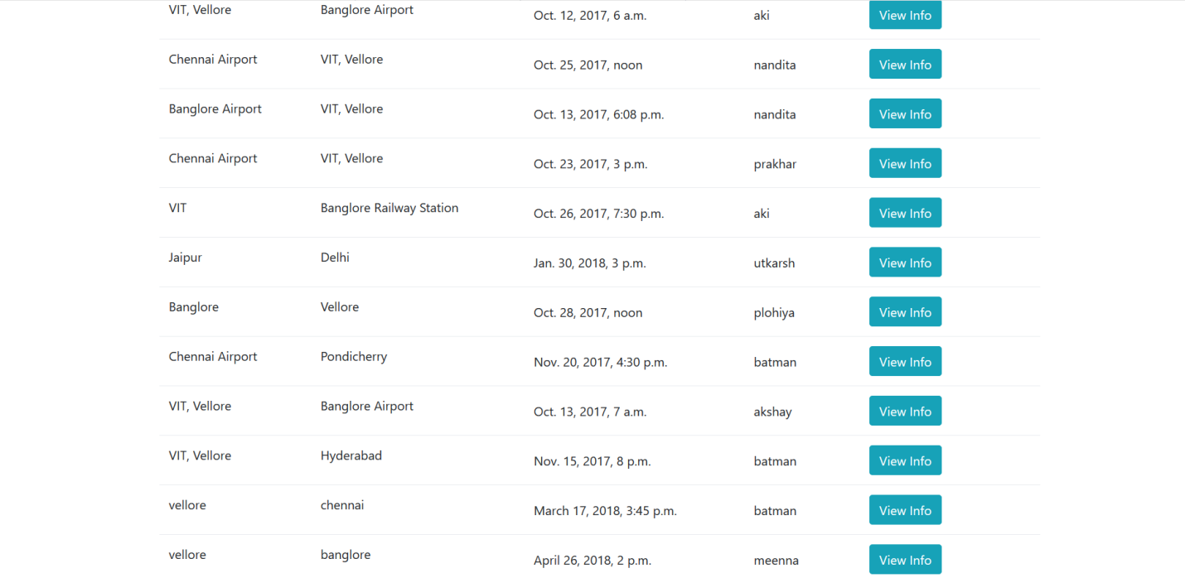

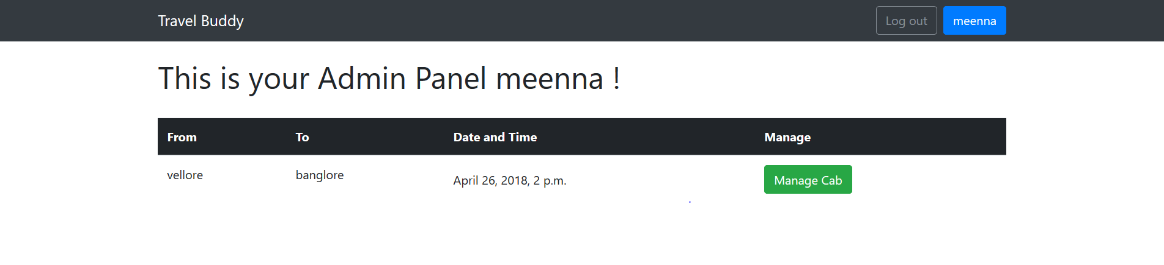

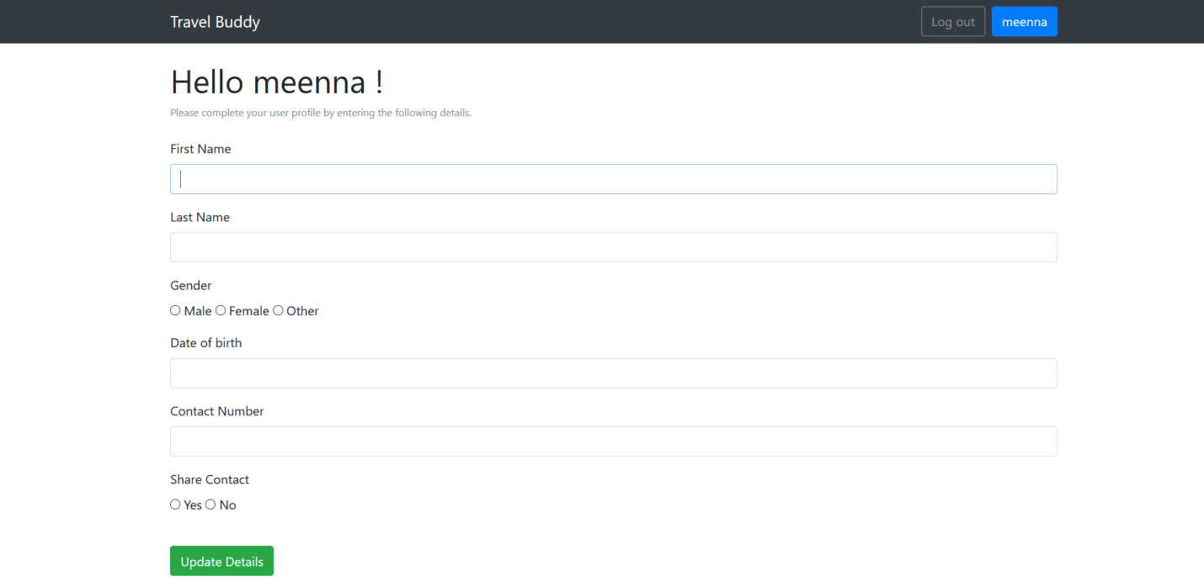

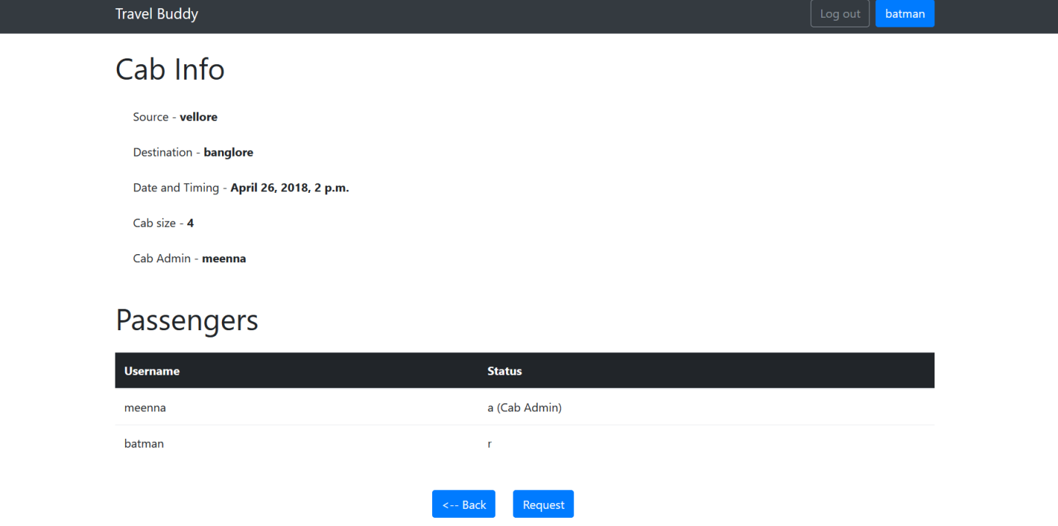

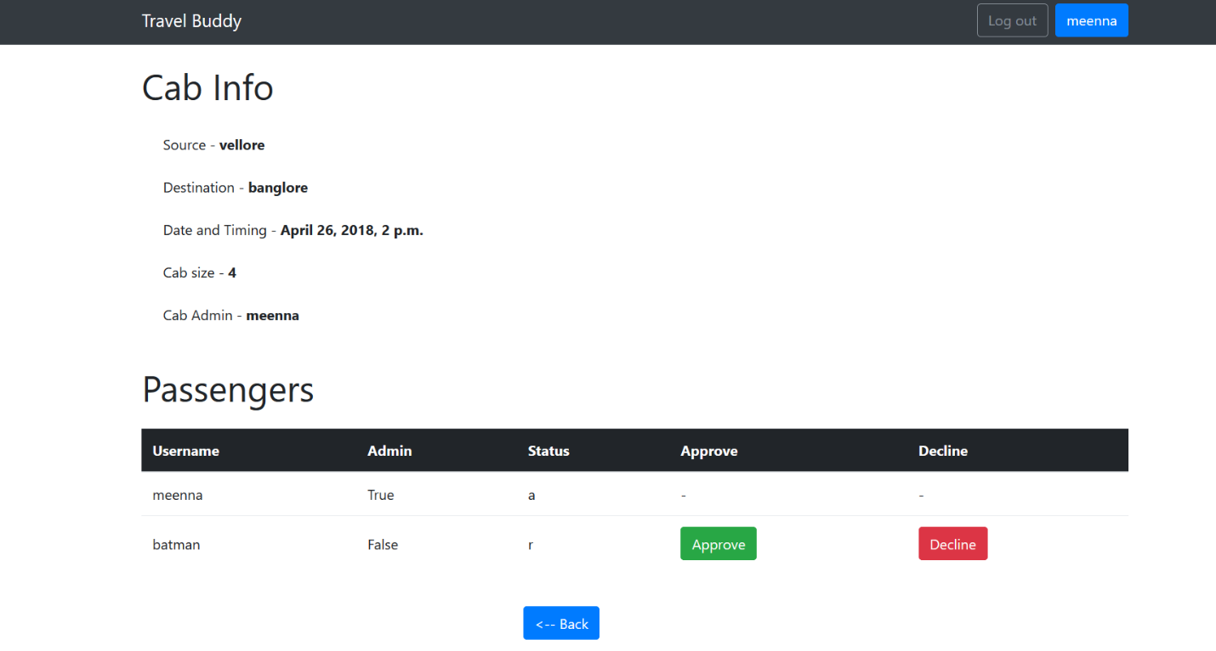

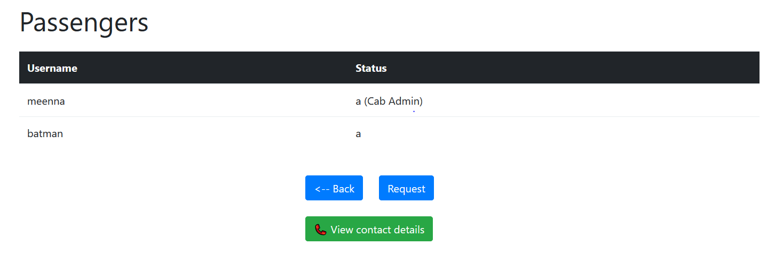

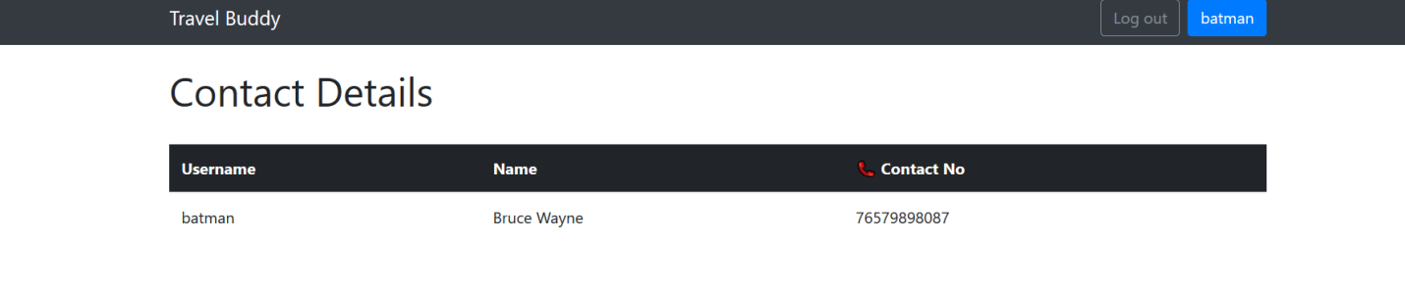

**USER MANUAL**

**Basic structure :**

